Experiment 2

**Name** : Mohammad Wasi

**SAP ID** : 500110709

**Batch** : AIML B8

Aim: To understand the concept of data constraints that is enforced on data being stored in the table. Focus on Primary Key and the Foreign Key.

**Objective :**

1. Create tables to store information about clients, products, and salesmen, incorporating data constraints.
2. Reinsert data into these tables based on Lab 1.
3. Display the contents of each table.
4. Create a new table 'AUTHOR' with specified constraints.
5. Create another table 'BOOK' with specified constraints.
6. Add records to 'AUTHOR', 'BOOK', and 'AUTHOR_LIST'.
7. Alter the structure of the 'AUTHOR_LIST' table by adding a new field 'Publisher'.

Theory :

**Primary Key:** A Primary Key is a unique identifier for a record in a table. It ensures data integrity by preventing duplicate entries, enabling efficient data retrieval and indexing.

**Foreign Key:** A Foreign Key establishes a link between two tables by referencing the Primary Key of another table. It maintains referential integrity, enforcing relationships and ensuring consistency in the database.

**Code**

create database WASI__DBMS__EXPERIMENT__2;

use WASI__DBMS__EXPERIMENT__2;;

**-- Create CLIENT_MASTER_1 table**

CREATE TABLE CLIENT__MASTER_1 (

CLIENTNO VARCHAR(6) PRIMARY KEY CHECK (CLIENTNO LIKE 'C%'),

NAME VARCHAR(20) NOT NULL,

CITY VARCHAR(15),

PINCODE INTEGER(8),

STATE VARCHAR(15),

BALDUE DECIMAL(10,2));

**-- Insert data into CLIENT_MASTER_1**

INSERT INTO CLIENT__MASTER_1 (CLIENTNO, NAME, CITY, PINCODE, STATE, BALDUE)

VALUES

('C00001', 'Ivan Bayross', 'Mumbai', 400054, 'Maharashtra', 15000),

('C00002', 'Mamta Muzumdar', 'Madras', 780001, 'Tamil Nadu', 0),

('C00003', 'Chhaya Bankar', 'Mumbai', 400057, 'Maharashtra', 5000),

('C00004', 'Ashwini Joshi', 'Bangalore', 560001, 'Karnataka', 0),

('C00005', 'Hansel Colaco', 'Mumbai', 400060, 'Maharashtra', 2000),

('C00006', 'Deepak Sharma', 'Mangalore', 560050, 'Karnataka', 0);

select* FROM CLIENT__MASTER_1;

**Output**

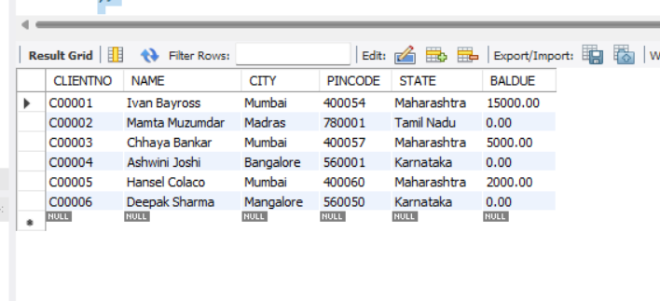

**-- Create PRODUCT_MASTER_1 table**

CREATE TABLE PRODUCT_MASTER_1 (

PRODUCTNO VARCHAR(6) PRIMARY KEY CHECK (PRODUCTNO LIKE 'P%'),

DESCRIPTION VARCHAR(15) NOT NULL,

PROFITPERCENT DECIMAL(4,2) NOT NULL,

UNIT_MEASURE VARCHAR(10) NOT NULL,

QTYONHAND INTEGER(8) NOT NULL,

REORDERL_VL INTEGER(8) NOT NULL,

SELLPRICE DECIMAL(8,2) NOT NULL,

COSTPRICE DECIMAL(8,2) NOT NULL);

**-- Insert data into PRODUCT_MASTER_1**

INSERT INTO PRODUCT_MASTER_1 (PRODUCTNO, DESCRIPTION, PROFITPERCENT, UNIT_MEASURE, QTYONHAND, REORDERL_VL, SELLPRICE, COSTPRICE)

VALUES

('P00001', 'T-Shirt', 5, 'Piece', 200, 50, 350, 250),

('P0345', 'Shirts', 6, 'Piece', 150, 50, 500, 350),

('P06734', 'Cotton Jeans', 5, 'Piece', 100, 20, 600, 450),

('P07865', 'Jeans', 5, 'Piece', 100, 20, 750, 500),

('P07868', 'Trousers', 2, 'Piece', 150, 50, 850, 550),

('P07885', 'Pull Overs', 2.5, 'Piece', 80, 30, 700, 450),

('P07965', 'Denim Jeans', 4, 'Piece', 100, 40, 350, 250),

('P07975', 'Lycra Tops', 5, 'Piece', 70, 30, 300, 175),

('P08865', 'Skirts', 5, 'Piece', 75, 30, 450, 300);

select* from PRODUCT_MASTER_1;

**Output**

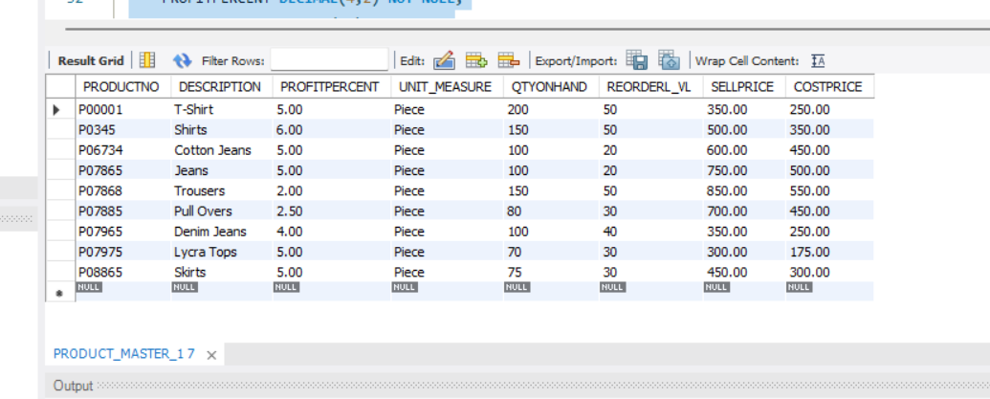

CREATE TABLE _SALESMAN_MASTER_1 (

SALESMANNO VARCHAR(6) PRIMARY KEY,

CONSTRAINT CHK_SALESMANNO CHECK (LEFT(SALESMANNO, 1) = 'S'),

SALESMANNAME VARCHAR(20) NOT NULL,

ADDRESS1 VARCHAR(30) NOT NULL,

ADDRESS2 VARCHAR(30),

CITY VARCHAR(20),

PINCODE INT,

STATE VARCHAR(20),

SALAMT REAL NOT NULL CHECK (SALAMT <> 0),

TGTTOGET DECIMAL(6,2) NOT NULL CHECK (TGTTOGET <> 0),

YTDSALES DOUBLE NOT NULL,

REMARKS VARCHAR(50)

);

INSERT INTO _SALESMAN_MASTER_1 (SALESMANNO, SALESMANNAME, ADDRESS1, ADDRESS2, CITY, PINCODE, STATE, SALAMT, TGTTOGET, YTDSALES, REMARKS)

VALUES

('S10001', 'John Doe', '123 Main Street', 'Apt 45', 'City1', 12345, 'State1', 1500.00, 500.00, 1200.50, 'Excellent Salesperson'),

('S10002', 'Jane Smith', '456 Oak Avenue', NULL, 'City2', 56789, 'State2', 1800.50, 600.00, 1500.75, 'Top Performer'),

('S10003', 'Bob Johnson', '789 Pine Road', 'Suite 12', 'City3', 98765, 'State3', 1200.75, 450.00, 900.25, 'Consistent Performer'),

('S10004', 'Alice Brown', '321 Cedar Lane', NULL, 'City4', 54321, 'State4', 2000.25, 700.00, 1800.00, 'Exceeding Targets');

**Output**

**-- Create AUTHOR table**

CREATE TABLE AUTHOR (

Author_ID INT PRIMARY KEY,

Lastname TEXT(15) NOT NULL,

Firstname TEXT(15) NOT NULL,

Email TEXT(40),

City TEXT(15),

Country TEXT(15));

**-- Insert data into AUTHOR**

INSERT INTO AUTHOR (Author_ID, Lastname, Firstname, Email, City, Country)

VALUES

(01, 'Doe', 'John', 'john.doe@example.com', 'New York', 'USA'),

(02, 'Smith', 'Jane', 'jane.smith@example.com', 'London', 'UK'),

(03, 'Johnson', 'Robert', 'robert.johnson@example.com', 'Paris', 'France'),

(04, 'Kim', 'Soo', 'soo.kim@example.com', 'Seoul', 'South Korea'),

(05, 'Brown', 'Emily', 'emily.brown@example.com', 'Sydney', 'Australia'),

(06, 'Singh', 'Rajesh', 'rajesh.singh@example.com', 'Mumbai', 'India'),

(07, 'Garcia', 'Maria', 'maria.garcia@example.com', 'Barcelona', 'Spain'),

(08, 'Wang', 'Li', 'li.wang@example.com', 'Beijing', 'China');

**Output**

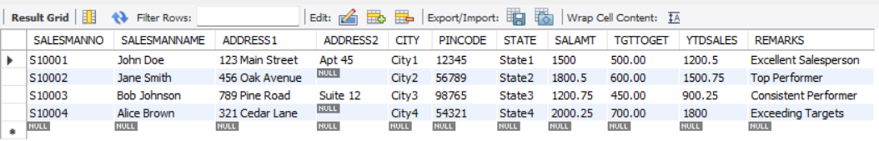

**-- Create BOOK table**

CREATE TABLE BOOK (

Book_ID varchar(5) PRIMARY KEY CHECK (Book_ID LIKE 'B%'),

Book_Title TEXT NOT NULL,

Copies INT CHECK (Copies > 2)

);

**-- Insert data into BOOK**

INSERT INTO BOOK (Book_ID, Book_Title, Copies)

VALUES

('B0001', 'The Catcher in the Rye', 5),

('B0002', 'To Kill a Mockingbird', 8),

('B0003', '1984', 10),

('B0004', 'Pride and Prejudice', 6),

('B0005', 'The Great Gatsby', 7),

('B0006', 'The Hobbit', 9),

('B0007', 'Brave New World', 12),

('B0008', 'The Odyssey', 5)

**Output**

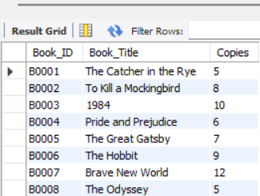;

**-- Create AUTHOR_LIST table**

CREATE TABLE AUTHOR__LIST (

Author_ID varchar(5) REFERENCES AUTHOR(Author_ID),

Book_ID varchar(5),

Role TEXT(15),

PRIMARY KEY (Author_ID, Book_ID));

**-- Alter structure of AUTHOR_LIST**

ALTER TABLE AUTHOR__LIST

ADD COLUMN Publisher TEXT(30);

**-- Insert data into AUTHOR_LIST**

INSERT INTO AUTHOR__LIST (Author_ID, Book_ID, Role, Publisher)

VALUES

('A0001', 'B0001', 'Author', 'Vintage Books'),

('A0002', 'B0002', 'Co-Author', 'Houghton Mifflin Harcourt'),

('A0003', 'B0003', 'Editor', 'Aldous Huxley Publishing'),

('A0004', 'B0004', 'Contributor', 'Homer Press');

**Output**

